Form 34 Pledge for the Lawful Use of Living Modified Organisms
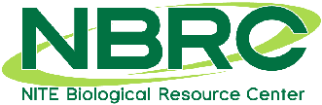
NBRC ® Culture Collection
2-5-8, Kazusa-kamatari, Kisarazu, Chiba 292-0818, Japan TEL: +81-438-20-5763, E-mail: nbrc-order@nite.go.jp

Pledge for the Lawful Use of Living Modified Organisms
To Director General
Biological Resource Center
National Institute of Technology and Evaluation

I, hereby pledge that, having the knowledge of the biological material(s) listed below that have been distributed to me by the Biological Resource Center, National Institute of Technology and Evaluation being a “Living Modified Organism(s)”, I/we shall use it/them under the proper “containment measure” as stipulated by the “Cartagena Protocol on Biosafety to the Convention on Biological Diversity”.

LIST
 | NBRC No. | Name of Biological Material(s)
1
2
3
4
5

Date:
Name:
Organization: Address:
Tel:
E-mail:

